**CHAPTER 1**

**INTRODUCTION**

* 1. **INTRODUCTION**

Artificial Intelligence is getting increasingly more advanced as time passes, making machines think and work in a insightful way. Gesture can be defined as a form of non-verbal communication, and also defined as the movements of face, hands or other body parts. When comes to gesture recognition can be done by Interpreting human gestures via AI and Deep learning, Gestures provides a way for computers to understand human body language. They are many advantages of this project with the help of this project we can control any smart device with out any human interaction this is very much useful for old aged people because they cant move or it is difficult for them to operate any technology but with this they life gets simpler in operating things. They are many tools for gesture recognition like leap motion controller. It is the technology that uses sensors to read the data and interpret some of the movements or commands done by any human body. This is done usually with out touching any physical buttons or screen of a system or smart device. In this project mainly I used or imported two packages namely OpenCV and pyautogui the first one open cv is used for capturing of the image from the webcam and detects the movements of the body in simple words it is used for video capturing, and the second package pyautogui is used for the movement of keys that is according to the information given by the OpenCV module it detects the movements and then accordingly manages to operate the keys.

They are many applications for this project like it can also be used in reality gaming i.e. we can play games like subway surfers and many more. In this games if we move towards right then the motion is recognised and automatically the right arrow is pressed applies same for all the directions. This is very useful even in smart cars with the help of our gestures we can control some features like song change of volume increase or decrease operation. Not only detection and controlling the objects it is a difficult task because the external light should be minimised the moments should be captured accurately the operation should be spontaneous .

* 1. **OBJECTIVES**

In our project there are many objectives. They can be listed as

* Remote controlling a smart device.
* Reality gaming using body detection.
* Robot control(controlling machines).
* Sign language recognition.

**1.3 METHODOLOGY**

* This is mainly based on object detection and controlling device.
* So mainly we need modules which can control this operations.
* The modules are 1) OpenCV 2) pyautogui.
* OpenCV is used for object tracking from the captured image.
* BOOSTING Tracker, KCF Tracker, MIL Tracker, TLD Tracker, MEDIANFLOW Tracker, GOTURN tracker, MOSSE tracker, CSRT tracker these are the trackers available in OpenCV for tracking the movement.
* Pyautogui is used for key press ( up, down, left, right arrow keys).
* Moving the mouse and clicking in the windows of other applications.

**CHAPTER 2**

**LITERATURE REVIEW**

Hand Gesture Recognition is a hardware-based and vision-based approach in Human-Computer Interaction. One of the earliest hardware-based methods, Quam argued for the use of data gloves to recognise people in 1990. The technique necessitated the user wearing a big data glove. It was inconvenient and hampered productivity. Certain HCI movements based on vision are further divided into approaches that include and exclude markers. The beginning At all times, the user must wear colour markers or colour caps. The latter is based on skin detection and hand detection concepts. Segmentation. In a variety of approaches, colour caps have been proposed for the detection of fingertips. The intensity of these pixels in the grayscale image distinguishes the fingertips from the rest of the frame. These techniques Stored frames, on the other hand, are not used to detect skin pixels or segment hands. Second, with a noisy background, accuracy is significantly lower than with a simple background.

A similar strategy was utilised by Siam et al., which comprised two steps: marker detection and marker tracking. The use of coloured markers cut down on computation time and enhanced the accuracy of gesture detection. They used the sliding window method, which, while effective, requires the use of powerful computers in order to produce better results. The precision of tracking has also been demonstrated.

**CHAPTER 3**

# **IMPLEMENTATION**

In this we discuss about the detailed working of software and hardware requirements, flowchart of framework.

## FLOW CHART

In our project, the operations are done one at a time In sequential order.

**3.1.1. GESTURE RECOGNITION**

Firstly our aim is to move or control the device with out any physical contact.so we need to capture the image from the web cam and according to that we need to move the object or the device to perform the task. For this we need highly advanced system with good specifications to meet the requirements of the project. This phase only plays the most important role in the entire project.

## Advantages of gesture recognition

* **With out any physical contact we can control the motion of objects**.
* Easy for old aged people for access of any technology.
* Speed and sufficient reliable for recognition system. Good performance system with complex background.
* Simple, fast and easy to implement. Can be applied in real system and play games.
* The system successfully recognises static and dynamic gestures. Could be applied on mobile robot control.

**Disadvantages gesture recognition**

* Recognition becomes difficult when the distance is greater than 1.5 meters between the object and camera.
* Ambient lighting effects the colour and body detection.
* Irrelevant objects may be detected when they are greater than the selected object.
* Very fast movements cannot be detected.

## METHODOLOGY FOR MOTION CONTROL USING GESTURE RECOGNITION

## The methodology of this project is shown in the below flow chart in Fig.3.1

## 

## Fig. 3.1 Flow Chart Of The Project

## Here firstly lets discuss how the code or working process is done. We need to start the system first then on the camera of the system. Run the code according to the code the web cam automatically captures the image which is in front of that. Then waits for the user input but internally the background noise and bulrush ness of the image is reduced or minimized. We need to select a particular region which we want to track from the captured image for this we have a option of reselection also. After selection the object is detected or saved in the memory for tracking next stage is that the web cam automatically on and the selected object is then detected as shown in the fig 3.2

## Fig. 3.2 Object Detected As Selected

## Then the detected image is opened in another box where the entire web cam video is displayed but the detected object is highlighted in a box structure. And also the box is displayed in a partition format as shown in the figure 3.3 it is because of user understanding. If suppose our hand is selected then as discussed the grid is divided if the hand enters the right grid box then the motion is detected and automatically the right arrow button is pressed by the pyautogui module. Same as it is if the hand enters the left grid bow the left arrow is pressed if entered in top box the up arrow is pressed and if moved to down field the down arrow is pressed. Not only the above mentioned specific keys we can define any key as of our wish according to our use. In our project we use the arrow keys so I define them for the use. As discussed we can open a chrome browser or a game and control it with our hand gestures only.

## 

## Fig. 3.3 Web Cam Image With Grid Box

## As our selected object enter any of the above specific grid then automatically that key is pressed with out any physical contact.

## SOFTWARE REQUIREMENT SPECIFICATIONS (SRS)

## HARDWARE REQUIREMENTS:

Processor : Min. Core i5 processor

Web cam : Min. 10MP

RAM : 4GB (Min.) or 8GB (Recommended)

Hard Disk Space : Min 50 GB free space

## SOFTWARE REQUIREMENTS

Operating System: Windows 10 or later versions of windows

Presentation Tier: python Idle

Business Tier : Python

## 3.2.1 TECHNOLOGYDESCRIPTION

## PYTHON

## Python is a high-level, general-purpose interpreted programming language. Its design philosophy emphasises readability of the code and makes significant use of meaningful symbols.

## Python is dynamically typed and garbage-collected. It supports structured (particularly procedural), object-oriented, and functional programming paradigms. It is frequently referred to as a "batteries included" language due to its vast standard library.

## Python was created in the late 1980s by Guido van Rossum as a replacement for the ABC programming language, and Python 0.9.0 was released in 1991.Python 2.0, released in 2000, added list comprehensions, cycle-detecting garbage collection, reference counting, and Unicode support. Python 3.0, which was released in 2008, was a major upgrade that was not fully backwards compatible with earlier versions. Guido van Rossum of Centrum Wiskunde & Informatica (CWI) in the Netherlands invented Python in the late 1980s as a replacement for the ABC programming language, which was influenced by SETL and could handle errors and communicate with the Amoeba operating system. It went into effect in December 1989. Van Rossum served as the project's sole developer until July 12, 2018, when he announced his "permanent vacation" from his position as Python's "benevolent dictator for life," a title awarded by the Python community in honour of his long-term devotion as the project's primary decision-maker. Active Python core developers chose a five-member Steering Council to lead the project in January 2019.

## Python 2.0 was published on October 16, 2000

## PYTHON FEATURES:

**1) Easy to Learn and Use:**

## In comparison to other programming languages, Python is simple to learn. Basic grammar is quite close to English. Indentation is used to define the code block rather than a semicolon and curly brackets. Beginners should use it.

**2)  Expressive Language:**

Python can do complex tasks with only a few lines of code. To run the hello world programme, for example, type print ("Hello World"). It will just take one line to run when compared to Java or C.

**3) Free and Open Source:**

Python is a free programming language that anybody may use. It is freely available on its official website, www.python.org. It has a large community working hard to produce new Python modules and functions all around the world. Everyone is invited to contribute to the Python community. "Its source code is freely available to anybody," states open-source.

**4)  Large Standard Library:**

It has a wide range of libraries for machine learning, web development, and scripting. Machine learning libraries include TensorFlow, Pandas, Numpy, Keras, and Pytorch, to name a few. Django, Flask, and Pyramids are Python web development frameworks.

**5)  Extensible:**

It means that we may build the code in other languages, such as C/C++, and utilise it in our Python work. It converts the programme into byte code that may be executed on any platform.

**CHAPTER 4**

**EXPERIMENTATION AND RESULTS**

In this chapter, implementation of flowchart or frame work is described. Results will be explained in terms of pictures.

**4.1 Experimental Work**

In our project, mainly the image is captured and the object is selected and detected according to the motion of the selected object the keys are automatically pressed. The min modules used in this process are as given below.

* OpenCV
* PyAutoGUI
* Time

## 4.1.1 IMPLEMENTATION OF MOTION CONTROL USING GESTURES

## STEP 1:

## This code is used for detection of the image which is captured from the tracker.

## 

## Fig. 4.1 code1

## STEP 2:

## Here in this code the game rules are set according to the coordinates and the area selection for the different applications

## 

## Fig. 4.2 code2

## STEP 3:

## Here in this code the boundary lines are drawn to partition the area for easy user understanding and controlling.

## Fig. 4.3 code3

## STEP 4:

## Here updation is done when the tracker by calling the drawbox fun the object moves in the video. And also the frame rate is printed even tracking details.

## Fig. 4.4 code4

## STEP 5:

## With this code we can exit the code.

## Fig. 4.5 code5

## STEP 6:

## Now we can run the entire code and enjoy the outcome. We can play games with reality gaming experience.

## For more accurate implementation we can even change the tracker and use high quality cameras.

**4.1.2 OUTPUT**

When the code is run the webcam captures image the specific region is selected from the image then another grid box is opened with the live cam and our live video moving and also the selected object when the object is moves according to the movement it enters s grid box then the key is pressed automatically which is assigned to that grid box.so in this way the output can be explained.

**4.2 RESULTS AND DISCUSSION**

The output of stage one is it takes the image and we need to select the object which need to be detected the same is shown in the below figure.

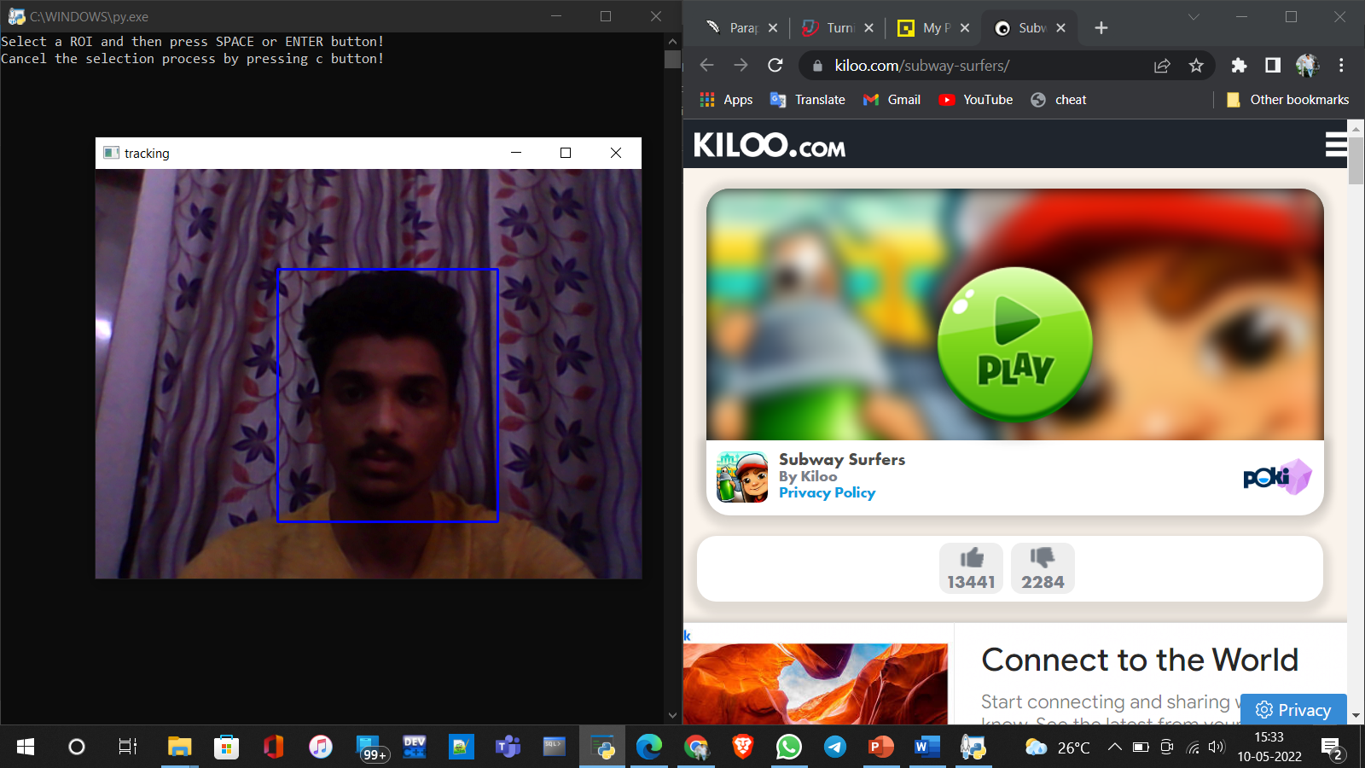

## Fig. 4.6 Result of step 1

## In the fig we can clearly see that the object or a part of region is being selected for object tracking.

## The next figure shows us the grid box output how it is create and also the frame rate is printed and the curser is placed at the selected region. The cursor moves with the movement of the body which can bee seen in the next figure

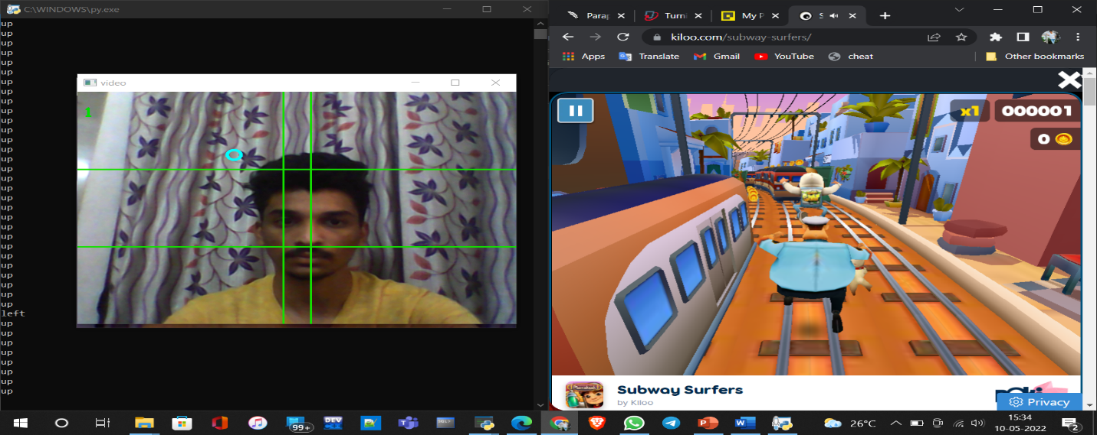

Fig. 4.7 Result of step 2

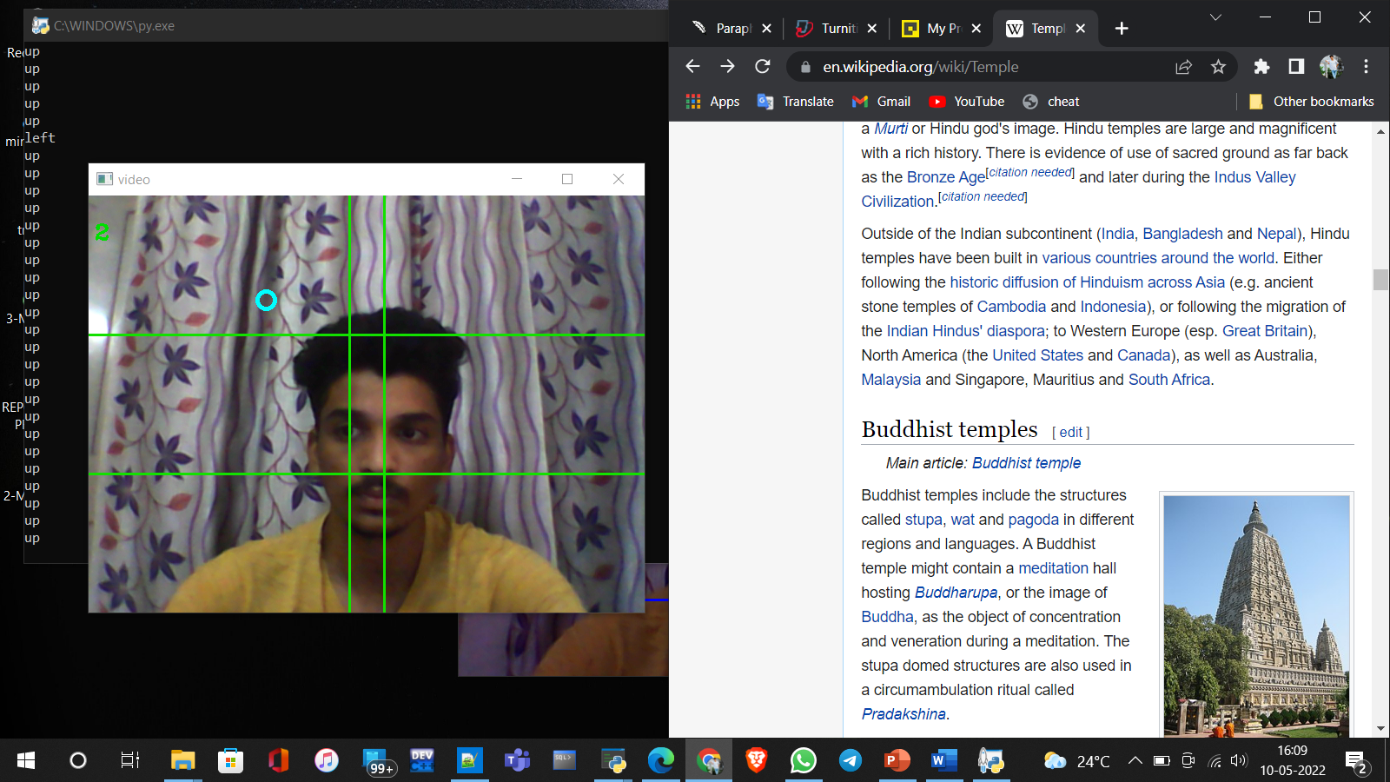Here with the help of this project I am able to paly a game in the next figures another application is shown where we can scroll the web browser with out any physical contact.

Fig. 4.8 Web browser scrolling up

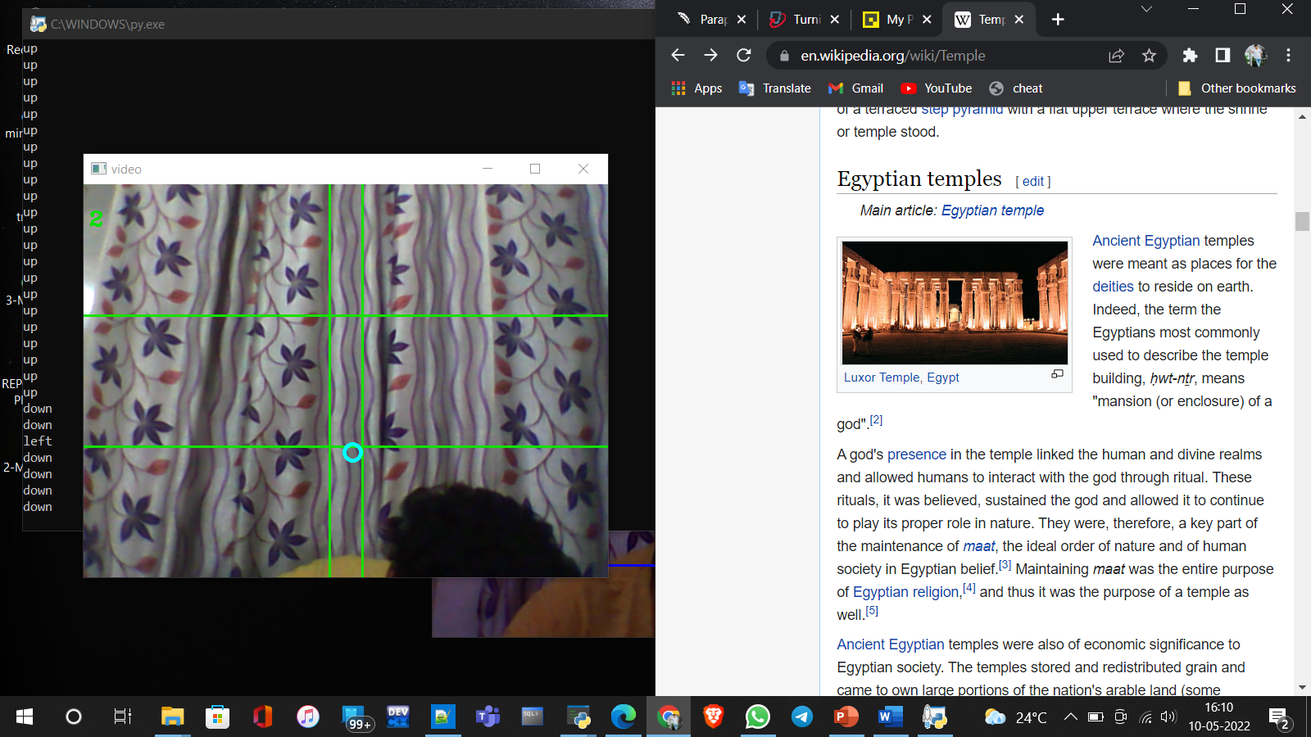

Fig. 4.9 Web browser scrolling down

We can implement this project in many other applications like cars where we can control the sound of the car with out an physical contact to buttons and also changing of songs. These are the outputs of the project and some application figures are shown above.

**CHAPTER 5**

**CONCLUSION AND FUTURE SCOPE**

**5.1. Conclusions**

The importance of gesture recognition lies in building efficient machine human interactions. The main aim is object detection application. The principal benefit of utilizing this is that it is simpler to control different types of systems, applications with out any physical contact. It can be extended into various real-world applications such as Digital Art, Reality Gaming, Virtual and Augmented Reality. This is especially valuable in present scenario of social distancing. The pandemic of COVID-19, made greater part of people inhabited for telecommuting this technology is very useful for such people. In controlling any of the robotic appliances this one of my favourite project I enjoyed a lot doing this not only it gives a good gaming experience but it also have very very important implementation. This concept is also well liked by small age children because they enjoy playing games. With this kind of non contact playing they even enjoy a lot.

**5.2. FUTURE SCOPE**

In this project we just used basic sensors and a basic web cam but by using high performance systems and good quality equipment we can have even more accurate results. This technology is not yet implemented in large scale by implementing we can keep cheque for many problems which are faced by children and mainly old aged people. We can make the appliances smart this mainly works on the internet of things application.